Journal Pages for Plants

Standards 3.2.1

Illustrate the life cycles of seed plants and various animals and summarize how they

grow and are adapted to conditions within their habitats.

Standards 3.2.2

Explain how physical and behavioral adaptations allow organisms to survive (including hibernation, defense, locomotion, movement, food obtainment, and camouflage for animals and seed dispersal, color, and response to light for plants).

Standards 3.2.3

Recall the characteristics of an organism’s habitat that allow the organism to survive there.

Standards: 3-2.4

Explain how changes in the habitats of plants and animals affect their survival.

Standards: 3.2.5

Summarize the organization of simple food chains (including the roles of producers, consumers, and decomposers).

1. What is a life cycle? ____________________________________________________________________________________________

2. What allows plants to go through a life cycle where all their needs are met? ____________________________________________________________________________________________

3. What are adaptations? _____________________________________________________________________________________________

4. An adaptation can help a plant do what in its habitat? _____________________________________________________________________________________________

5. What are all the components of a plant’s habitat?

* ____________________
* ____________________
* ____________________
* ____________________
* ____________________
* ____________________

6. What are the three stages that a seed plant goes through?

a) _____________________ b) ________________________ c) _______________________

7. ***Stage 1: Seed***

This diagram is the first stage of a seed plant’s life. What is this stage? _________________________

[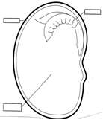](http://rds.yahoo.com/_ylt=A0PDoX2GA59NrAkA.1mJzbkF;_ylu=X3oDMTBpaWhqZmNtBHBvcwMzBHNlYwNzcgR2dGlkAw--/SIG=1pq1i2tb9/EXP=1302295558/**http:/images.search.yahoo.com/images/view?back=http%3A%2F%2Fimages.search.yahoo.com%2Fsearch%2Fimages%3Fp%3Dparts%2Bof%2Ba%2Bseed%26ei%3DUTF-8%26fr%3Dyfp-t-701&w=495&h=573&imgurl=ryecityschools.milton.schoolfusion.us%2Fmodules%2Fgroups%2Fhomepagefiles%2Fcms%2F496886%2FImage%2FWebquests%2FPlants%2Fparts%2520of%2520a%2520seed.gif&rurl=http%3A%2F%2Fryecityschools.milton.schoolfusion.us%2Fmodules%2Fcms%2Fpages.phtml%3Fsessionid%3D3d83620435daf9c714ac5963%26pageid%3D107163%26sessionid%3D3d83620435daf9c714ac5963&size=27KB&name=Milton+School+-+...&p=parts+of+a+seed&oid=c58e47e7a4ee494256a13ca079d7d120&fr2=&no=3&tt=424000&sigr=14oqif77e&sigi=13uvbvc9u&sigb=12kqkl47r&.crumb=5L4N1FN) How is a seed produced? _____________________________________________________________________

What are the parts found inside of a seed? a)___________________ b)___________________ c)__________________

Label the parts of this seed below.

[](http://rds.yahoo.com/_ylt=A0PDoX2GA59NrAkA.1mJzbkF;_ylu=X3oDMTBpaWhqZmNtBHBvcwMzBHNlYwNzcgR2dGlkAw--/SIG=1pq1i2tb9/EXP=1302295558/**http:/images.search.yahoo.com/images/view?back=http%3A%2F%2Fimages.search.yahoo.com%2Fsearch%2Fimages%3Fp%3Dparts%2Bof%2Ba%2Bseed%26ei%3DUTF-8%26fr%3Dyfp-t-701&w=495&h=573&imgurl=ryecityschools.milton.schoolfusion.us%2Fmodules%2Fgroups%2Fhomepagefiles%2Fcms%2F496886%2FImage%2FWebquests%2FPlants%2Fparts%2520of%2520a%2520seed.gif&rurl=http%3A%2F%2Fryecityschools.milton.schoolfusion.us%2Fmodules%2Fcms%2Fpages.phtml%3Fsessionid%3D3d83620435daf9c714ac5963%26pageid%3D107163%26sessionid%3D3d83620435daf9c714ac5963&size=27KB&name=Milton+School+-+...&p=parts+of+a+seed&oid=c58e47e7a4ee494256a13ca079d7d120&fr2=&no=3&tt=424000&sigr=14oqif77e&sigi=13uvbvc9u&sigb=12kqkl47r&.crumb=5L4N1FN)

What does the word germinate mean? The diagram below illustrates germination occurring.

________________________________________

What does plant need to germinate? __________________________________________________________________

8. ***Stage 2: Seedling***

This diagram is the second stage of a seed plant’s life. What is this stage? _______________________________

[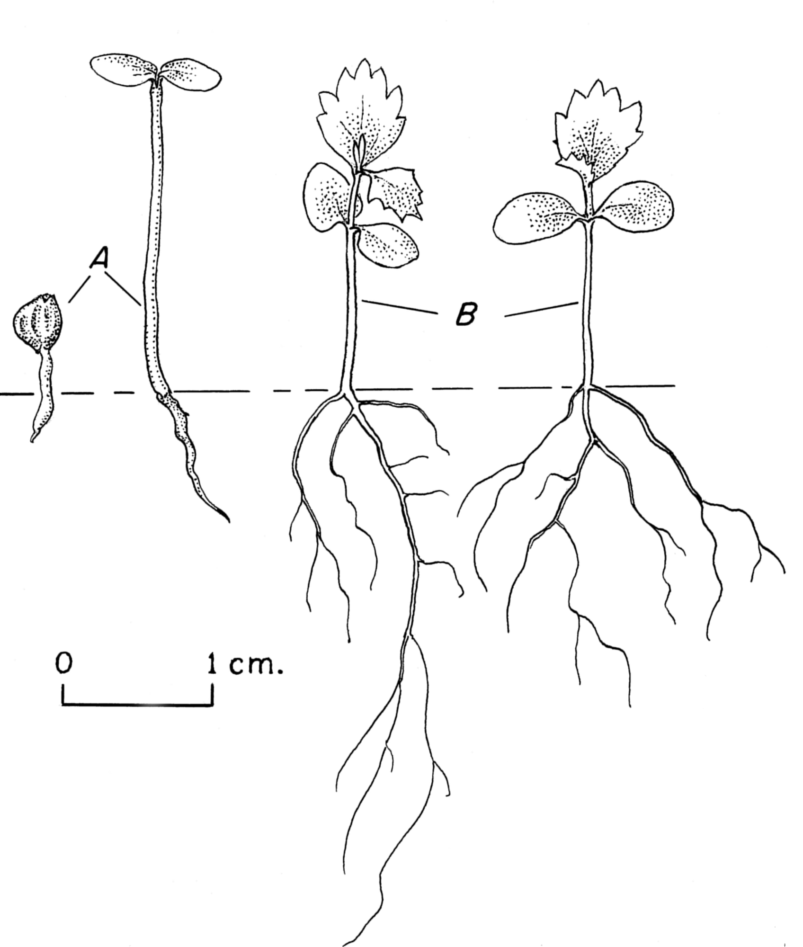](http://rds.yahoo.com/_ylt=A0PDoX0nBJ9N6wYAIfWjzbkF/SIG=131vsticp/EXP=1302295719/**http:/upload.wikimedia.org/wikipedia/commons/9/90/Alnus_seedling_drawing)

What does a seedling produce that is so important for the adult plant to survive? ____________________________________________________________________________________________

What are roots? ____________________________________________________________________________________________

How are roots important? ____________________________________________________________________________________________

Label the roots on the diagram below.

[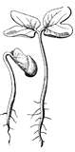](http://rds.yahoo.com/_ylt=A0PDoX2CBJ9N6wYAOAGJzbkF;_ylu=X3oDMTBpdnJhMHUzBHBvcwMxBHNlYwNzcgR2dGlkAw--/SIG=1hupefd9f/EXP=1302295810/**http:/images.search.yahoo.com/images/view?back=http%3A%2F%2Fimages.search.yahoo.com%2Fsearch%2Fimages%3Fp%3Dseedling%2Bclipart%26ei%3Dutf-8%26fr%3Dyfp-t-701&w=347&h=700&imgurl=etc.usf.edu%2Fclipart%2F4700%2F4733%2Fseedling_1_lg.gif&rurl=http%3A%2F%2Fetc.usf.edu%2Fclipart%2F4700%2F4733%2Fseedling_1.htm&size=14KB&name=Seedling+Clipart&p=seedling+clipart&oid=6f328f72fc8e1b44788a815c11001748&fr2=&no=1&tt=244&sigr=11jpqnus1&sigi=11fhgbbfr&sigb=12l0fs824&.crumb=5L4N1FN)

What is the stem? ________________________________________________________________________________

Label the stem on the diagram below.

[](http://rds.yahoo.com/_ylt=A0PDoX2CBJ9N6wYAOAGJzbkF;_ylu=X3oDMTBpdnJhMHUzBHBvcwMxBHNlYwNzcgR2dGlkAw--/SIG=1hupefd9f/EXP=1302295810/**http:/images.search.yahoo.com/images/view?back=http%3A%2F%2Fimages.search.yahoo.com%2Fsearch%2Fimages%3Fp%3Dseedling%2Bclipart%26ei%3Dutf-8%26fr%3Dyfp-t-701&w=347&h=700&imgurl=etc.usf.edu%2Fclipart%2F4700%2F4733%2Fseedling_1_lg.gif&rurl=http%3A%2F%2Fetc.usf.edu%2Fclipart%2F4700%2F4733%2Fseedling_1.htm&size=14KB&name=Seedling+Clipart&p=seedling+clipart&oid=6f328f72fc8e1b44788a815c11001748&fr2=&no=1&tt=244&sigr=11jpqnus1&sigi=11fhgbbfr&sigb=12l0fs824&.crumb=5L4N1FN)

What forms after the roots and stem? _____________________________

How are the leaves important to the plant’s survival? _____________________________________________________________________________________________

Label the leaves on the diagram below.

[](http://rds.yahoo.com/_ylt=A0PDoX2CBJ9N6wYAOAGJzbkF;_ylu=X3oDMTBpdnJhMHUzBHBvcwMxBHNlYwNzcgR2dGlkAw--/SIG=1hupefd9f/EXP=1302295810/**http:/images.search.yahoo.com/images/view?back=http%3A%2F%2Fimages.search.yahoo.com%2Fsearch%2Fimages%3Fp%3Dseedling%2Bclipart%26ei%3Dutf-8%26fr%3Dyfp-t-701&w=347&h=700&imgurl=etc.usf.edu%2Fclipart%2F4700%2F4733%2Fseedling_1_lg.gif&rurl=http%3A%2F%2Fetc.usf.edu%2Fclipart%2F4700%2F4733%2Fseedling_1.htm&size=14KB&name=Seedling+Clipart&p=seedling+clipart&oid=6f328f72fc8e1b44788a815c11001748&fr2=&no=1&tt=244&sigr=11jpqnus1&sigi=11fhgbbfr&sigb=12l0fs824&.crumb=5L4N1FN)

9. ***Stage 3: Mature Plant***

This diagram shows the last stage in a seed plant’s life. What stage is this? ___________________________

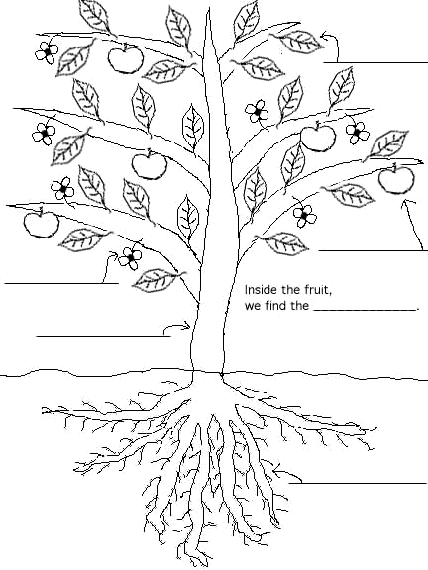

How are the mature plants similar to seedlings? _____________________________________________________________________________________________

How are the mature plants different from seedlings?

_____________________________________________________________________________________________

How are flowers and cones important in the life cycle of a plant? _____________________________________________________________________________________________

Label the diagram below of a flower and a cone.

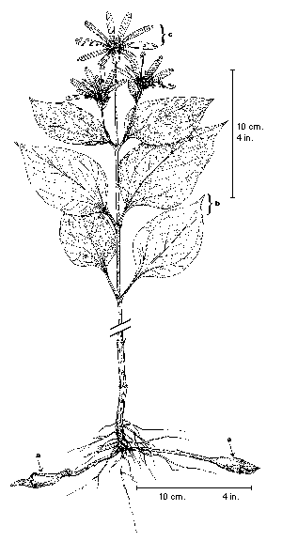 ___________ [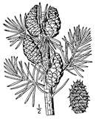](http://rds.yahoo.com/_ylt=A0PDoX6L.qJNmAQAktyJzbkF;_ylu=X3oDMTBqN29sN2NkBHBvcwM0MwRzZWMDc3IEdnRpZAM-/SIG=1mbqi7fkb/EXP=1302555403/**http:/images.search.yahoo.com/images/view?back=http%3A%2F%2Fimages.search.yahoo.com%2Fsearch%2Fimages%3Fp%3Dplants%2Bwith%2Bcones%2Bclip%2Bart%26b%3D41%26ni%3D20%26ei%3Dutf-8%26xargs%3D0%26pstart%3D1&w=2356&h=2896&imgurl=upload.wikimedia.org%2Fwikipedia%2Fcommons%2F9%2F9a%2FPinus_banksiana_drawing.png&rurl=http%3A%2F%2Fpt.wikipedia.org%2Fwiki%2FFicheiro%3APinus_banksiana_drawing.png&size=241KB&name=Ficheiro%3APinus+b...&p=plants+with+cones+clip+art&oid=aca14d36e6b7f11e77dbd1a50069a50a&fr2=&no=43&tt=136&b=41&ni=20&sigr=121f16ge4&sigi=127rho9db&sigb=13etubfke&.crumb=5L4N1FN/)______________

**Adaptations of Seed Plants:**

How are adaptations so important to a plant’s survival? ____________________________________________________________________________________________

**Roots:**

1. What is the role of the roots in a plant? _____________________________________________________________________________________________

2. Are all roots the same? _______________________________________________________________________

3. Look at the different types of roots below. Label the carrots, dandelions, water lilies and cacti roots.

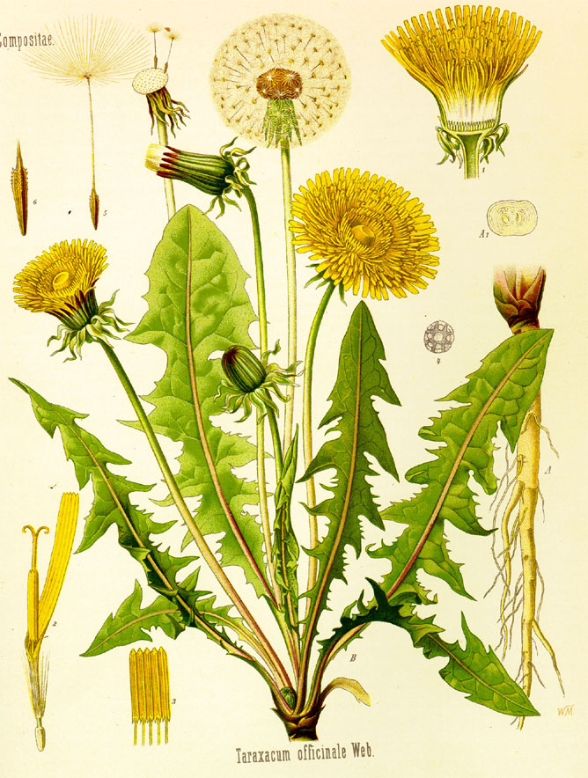[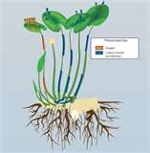](http://rds.yahoo.com/_ylt=A0PDoYAoBqNN82wAVR6JzbkF;_ylu=X3oDMTBqMGphbm9uBHBvcwMyMARzZWMDc3IEdnRpZAM-/SIG=1lp0cgc5j/EXP=1302558376/**http:/images.search.yahoo.com/images/view?back=http%3A%2F%2Fimages.search.yahoo.com%2Fsearch%2Fimages%3Fp%3Dwater%2Blilly%2Broots&w=600&h=611&imgurl=www.nature.com%2Fscitable%2Fcontent%2Fne0000%2Fne0000%2Fne0000%2Fne0000%2F17074376%2Ff3_cherry_ksm.jpg&rurl=http%3A%2F%2Fwww.nature.com%2Fscitable%2Fknowledge%2Flibrary%2Fecology-of-wetland-ecosystems-water-substrate-and-17059765&size=78KB&name=...+Pressurized+...&p=water+lilly+roots&oid=7d2024c2e10f53071b7cdefb490f6b05&fr2=&spell_query=water+lily+roots&no=20&tt=9350&sigr=13bot3qht&sigi=12mlb147j&sigb=120k6crqn&.crumb=5L4N1FN/)[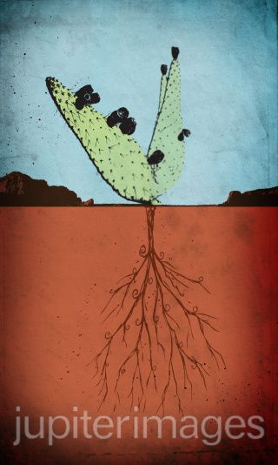](http://cache2.asset-cache.net/xc/84751635.jpg?v=1&amp;c=IWSAsset&amp;k=2&amp;d=EDF6F2F4F969CEBD861E02B89DED3CA0738E858B002343C0EED0DAA8070BA8AAE30A760B0D811)[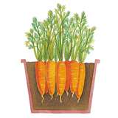](http://rds.yahoo.com/_ylt=A0PDoYCKBqNNa3gAqVeJzbkF;_ylu=X3oDMTBqamdoM3Q5BHBvcwMxMgRzZWMDc3IEdnRpZAM-/SIG=1iou67hmg/EXP=1302558474/**http:/images.search.yahoo.com/images/view?back=http%3A%2F%2Fimages.search.yahoo.com%2Fsearch%2Fimages%3Fp%3Dcarrots%2Broots&w=1000&h=1000&imgurl=www.thompson-morgan.com%2Fmedias%2Fsys_tandm%2F8796355493918.jpg&rurl=http%3A%2F%2Fwww.thompson-morgan.com%2Fvegetables%2Fvegetable-seeds%2Froot-vegetable-seeds%2Fcarrot-mokum%2F760TM&size=184KB&name=Carrot+Mokum+F1+...&p=carrots+roots&oid=c177e2e87624a14c29d51641b882c658&fr2=&no=12&tt=56600&sigr=131ov8moh&sigi=11qbbf636&sigb=11sspgil0&.crumb=5L4N1FN/)

_________________ ____________________ ________________ ________________

a). What are water lilies roots like? _____________________________________________________________________________________________

b) What are cacti roots like? _____________________________________________________________________________________________

c) What are carrot roots like? _____________________________________________________________________________________________

d) What are dandelion roots like? _____________________________________________________________________________________________

4. How does the plant benefit from having its adapted roots? _____________________________________________________________________________________________

**Stems:**

1. What is the role of the stem in a plant? _____________________________________________________________________________________________

2. What are some protections that some stems may have? _____________________________________________________________________________________________

3. Look at the different types of stems below. Label the vines, corn , sunflower, tree and cacti stems.

_________ ____________ ______________ ___________ _____________

[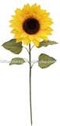](http://rds.yahoo.com/_ylt=A0PDoYC6BqNN2xwAPQ.JzbkF;_ylu=X3oDMTBpZm5udGl1BHBvcwM1BHNlYwNzcgR2dGlkAw--/SIG=1iv826ggb/EXP=1302558522/**http:/images.search.yahoo.com/images/view?back=http%3A%2F%2Fimages.search.yahoo.com%2Fsearch%2Fimages%3Fp%3Dsunflower%2Bstem%26ei%3Dutf-8&w=917&h=1901&imgurl=i00.i.aliimg.com%2Fphoto%2Fv0%2F239537024%2FArtificial_Sunflower_Stem.jpg&rurl=http%3A%2F%2Fwww.alibaba.com%2Fproduct-gs%2F239537024%2FArtificial_Sunflower_Stem%2Fshowimage.html&size=100KB&name=Artificial+Sunfl...&p=sunflower+stem&oid=51c0b46dd69d10ae650f964dbf2ccad5&fr2=&no=5&tt=17400&sigr=12k4b4inb&sigi=121jb4r44&sigb=126koj5fi&.crumb=5L4N1FN/) [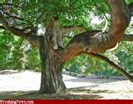](http://rds.yahoo.com/_ylt=A0PDoYBdB6NN2m8ALgaJzbkF;_ylu=X3oDMTBqYWdlNjBlBHBvcwMxOARzZWMDc3IEdnRpZAM-/SIG=1gkvcaogg/EXP=1302558685/**http:/images.search.yahoo.com/images/view?back=http%3A%2F%2Fimages.search.yahoo.com%2Fsearch%2Fimages%3Fp%3Dtree%2Bstems%26rs%3D2&w=650&h=510&imgurl=www.freakingnews.com%2Fpictures%2F27500%2FTree-27793.jpg&rurl=http%3A%2F%2Fwww.freakingnews.com%2FTree-Pics-34026.asp&size=248KB&name=Tree+Pics+-+High...&p=tree+stems&oid=60b59fd2fb712e51e351400af6000178&fr2=&no=18&tt=228000&sigr=11fnpj6qr&sigi=11i32bdli&sigb=11uf9trem&.crumb=5L4N1FN/) 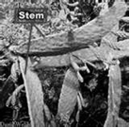 [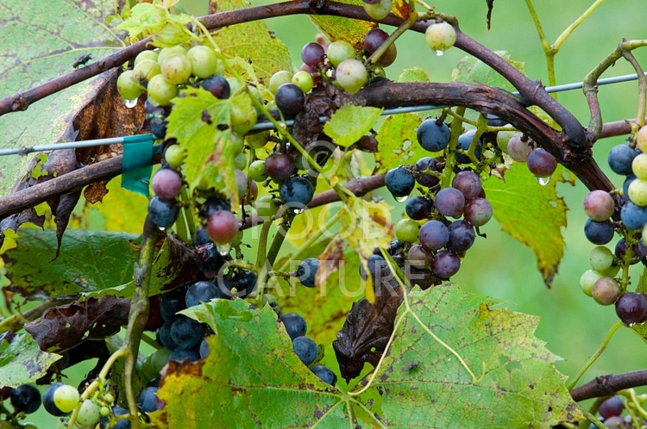](http://rds.yahoo.com/_ylt=A0PDoTFiCaNNRCUAlEijzbkF/SIG=134ge68sa/EXP=1302559202/**http:/c.photoshelter.com/img-get/I00001jZCSn_4AI0/s/750/Grapes-on-Vine-3491.) 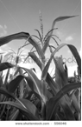

a) What are vine stems like? _____________________________________________________________________________________________

b) How are sunflower and corn stems like? _____________________________________________________________________________________________

c) What are tree stems like? _____________________________________________________________________________________________

d) What are cacti stems like? _____________________________________________________________________________________________

4. How does the plant benefit from having its adapted stem? _____________________________________________________________________________________________

**Leaves:**

1. What is the role of a leaf on a plant? _____________________________________________________________________________________________

2. What the different adaptations of leaves that help plants survive?

* _____________
* _____________
* ____________
* ____________

3. Look at the different types of leaves below. Label them as either water lilies and evergreens. [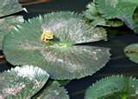](http://rds.yahoo.com/_ylt=A0PDoTBsmqVNZ2UAmGOJzbkF;_ylu=X3oDMTBpdDZuNzZrBHBvcwM5BHNlYwNzcgR2dGlkAw--/SIG=1lcjm2vvo/EXP=1302727404/**http%3a/images.search.yahoo.com/images/view%3fback=http%253A%252F%252Fimages.search.yahoo.com%252Fsearch%252Fimages%253Fp%253Dwater%252Blily%252Bleaves%2526norw%253D1%2526ei%253DUTF-8%2526fr%253Dyfp-t-701%2526fr2%253Dsp-qrw-corr-top%26w=800%26h=570%26imgurl=i.pbase.com%252Fo4%252F50%252F673750%252F1%252F65062181.h0LH87jQ.IMG_5447.jpg%26rurl=http%253A%252F%252Fwww.pbase.com%252Ftarzan1234%252Fimage%252F65062181%26size=292KB%26name=...%2bgalleries%2b%2526gt%253B%2526gt%253B...%26p=water%2blily%2bleaves%26oid=ad55281ac9ff82d4b5220a70ed80098a%26fr2=sp-qrw-corr-top%26norw=1%26no=9%26tt=60200%26sigr=11e7ta52m%26sigi=11pc1g300%26sigb=13hij9f02%26.crumb=5L4N1FN/y) [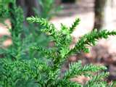](http://rds.yahoo.com/_ylt=A0PDoX_rmqVNXW8AikeJzbkF;_ylu=X3oDMTBpcWpidGtpBHBvcwM4BHNlYwNzcgR2dGlkAw--/SIG=1lc3t5dg0/EXP=1302727531/**http%3a/images.search.yahoo.com/images/view%3fback=http%253A%252F%252Fimages.search.yahoo.com%252Fsearch%252Fimages%253Fp%253Devergreen%252Bleaves%252Bof%252Btrees%2526sado%253D1%2526ei%253Dutf-8%2526fr%253Dyfp-t-701%2526fr2%253Dsg-gac%26w=2048%26h=1536%26imgurl=www.my-photo-gallery.com%252Fwp-content%252Fuploads%252F2009%252F09%252Fleaves-of-Japanese-cedar.jpg%26rurl=http%253A%252F%252Fwww.my-photo-gallery.com%252Ftag%252Ftree-houses%252F%26size=636KB%26name=leaves%2bof%2bJapane...%26p=evergreen%2bleaves%2bof%2btrees%26oid=6ca4e36dfec52615bbab0c32599f3591%26fr2=sg-gac%26no=8%26tt=69800%26sigr=11gh81uqf%26sigi=12gdfuc07%26sigb=13getsr9a%26.crumb=5L4N1FN/y)

a) What are water lily leaves like? _____________________________________________________________________________________________

b) What are evergreen tree leaves like? _____________________________________________________________________________________________

**Flowers:**

1. What are some of the adaptations that flowers have?

* ______________________
* _____________________
* _____________________
* ______________________

2. Why does the flower has these special adaptations? _____________________________________________________________________________________________

[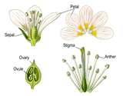](http://rds.yahoo.com/_ylt=A0PDoX4im6VN50UAsD6JzbkF;_ylu=X3oDMTBpc2ozM2gzBHBvcwM0BHNlYwNzcgR2dGlkAw--/SIG=1l5lb73ub/EXP=1302727586/**http%3a/images.search.yahoo.com/images/view%3fback=http%253A%252F%252Fimages.search.yahoo.com%252Fsearch%252Fimages%253Fp%253Dflowers%252Bpollinated%252Bby%252Binsects%2526sado%253D1%2526ei%253Dutf-8%2526fr%253Dyfp-t-701%2526fr2%253Dsg-gac%26w=1800%26h=1407%26imgurl=www.isu.edu%252F%257Efultjess%252FPollinators%252FGraphics%252FFlower.gif%26rurl=http%253A%252F%252Fwww.isu.edu%252F%257Efultjess%252FPollinators%252Fpollination.html%26size=534KB%26name=...%2bunderstand%2bt...%26p=flowers%2bpollinated%2bby%2binsects%26oid=a792e6f67c7a4c33f91c1e13a6493e50%26fr2=sg-gac%26no=4%26tt=9380%26sigr=11pto92av%26sigi=11ldv33ao%26sigb=13k6atdt3%26.crumb=5L4N1FN/y) [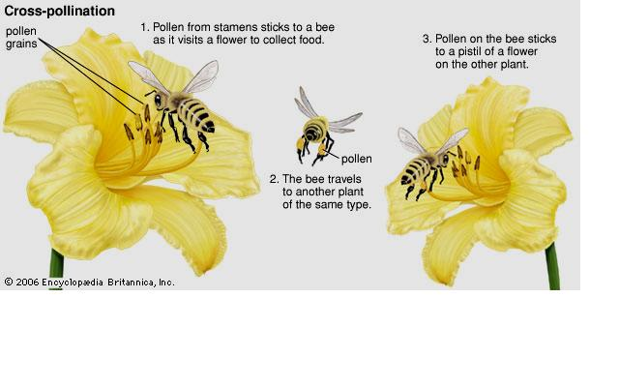](http://rds.yahoo.com/_ylt=A0PDoX46m6VNrjwAQaCjzbkF/SIG=13r0kveb7/EXP=1302727610/**http%3a/4.bp.blogspot.com/_DggqygQDzFg/S783g5UrinI/AAAAAAAAACQ/M3C20yJGeDc/s1600/cross%2bpollination.J)

**Fruit:**

1. What does the fruit protect? ________________

2. What are some of the adaptations that fruits have?

* _______________________________________
* _______________________________________

3. Label the fruits that are moist and fleshy.

[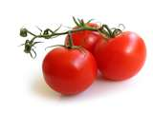](http://rds.yahoo.com/_ylt=A0PDoS.Vm6VN.0cA8O.JzbkF;_ylu=X3oDMTBpZTByOGFiBHBvcwMyBHNlYwNzcgR2dGlkAw--/SIG=1i9blksdq/EXP=1302727701/**http%3a/images.search.yahoo.com/images/view%3fback=http%253A%252F%252Fimages.search.yahoo.com%252Fsearch%252Fimages%253Fp%253Dtomato%2526fr2%253Dsg-gac%26w=2800%26h=2100%26imgurl=sonomaonthecheap.com%252Fwp-content%252Fuploads%252F2010%252F08%252Ftomato.jpg%26rurl=http%253A%252F%252Fsonomaonthecheap.com%252F2010%252F09%252Flabor-day-heirloom-tomato-cuvee-tasting%252F%26size=2MB%26name=tomato%2b150x150%2bL...%26p=tomato%26oid=777a71f925dc94776af6d001b7b94b60%26fr2=sg-gac%26no=2%26tt=2480000%26sigr=12clpivs5%26sigi=11qk9tbcb%26sigb=120295ntp%26.crumb=5L4N1FN/y) [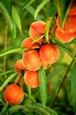](http://rds.yahoo.com/_ylt=A0PDoS_Fm6VN5k0Aa..JzbkF;_ylu=X3oDMTBpdDZuNzZrBHBvcwM5BHNlYwNzcgR2dGlkAw--/SIG=1ia772dpp/EXP=1302727749/**http%3a/images.search.yahoo.com/images/view%3fback=http%253A%252F%252Fimages.search.yahoo.com%252Fsearch%252Fimages%253Fp%253Dpeaches%2526ei%253Dutf-8%2526y%253DSearch%26w=640%26h=970%26imgurl=upload.wikimedia.org%252Fwikipedia%252Fcommons%252Fd%252Fd5%252FFlameprince_peaches.jpg%26rurl=http%253A%252F%252Fcommons.wikimedia.org%252Fwiki%252FImage%253AFlameprince_peaches.jpg%26size=99KB%26name=File%253AFlameprince...%26p=peaches%26oid=5304e86a767533c405ea02c3642a46a6%26fr2=%26no=9%26tt=673000%26sigr=11vvacuv1%26sigi=123tk609d%26sigb=128imda7e%26.crumb=5L4N1FN/y) [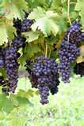](http://rds.yahoo.com/_ylt=A0PDoS_ym6VNI00AxTSJzbkF;_ylu=X3oDMTBpaWhqZmNtBHBvcwMzBHNlYwNzcgR2dGlkAw--/SIG=1jc9sls4d/EXP=1302727794/**http%3a/images.search.yahoo.com/images/view%3fback=http%253A%252F%252Fimages.search.yahoo.com%252Fsearch%252Fimages%253Fp%253Dgrapes%2526ei%253Dutf-8%2526y%253DSearch%26w=455%26h=683%26imgurl=www.piercemattiepublicrelations.com%252Ffitnessdivision%252FHangingGrapes.jpg%26rurl=http%253A%252F%252Fwww.piercemattiepublicrelations.com%252Ffitnessdivision%252F2009%252F09%252Fwinery_marketing_journal_of_nu.html%26size=51KB%26name=...%2bto%2bdrink%2bmor...%26p=grapes%26oid=786d95adfd2eec1f8e289fcfd3bcde5d%26fr2=%26no=3%26tt=1020000%26sigr=1368vtok4%26sigi=125nrgrt7%26sigb=1273folo6%26.crumb=5L4N1FN/y)

4. How does being moist and fleshy help the fruit with seed dispersal? _____________________________________________________________________________________________

5. Label the fruits that are dry and hard.

[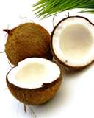](http://rds.yahoo.com/_ylt=A0PDoS8lnKVN20MAFpGJzbkF;_ylu=X3oDMTBqNzBoY2J0BHBvcwMxNARzZWMDc3IEdnRpZAM-/SIG=1i2ovfvgs/EXP=1302727845/**http%3a/images.search.yahoo.com/images/view%3fback=http%253A%252F%252Fimages.search.yahoo.com%252Fsearch%252Fimages%253Fp%253Dcoconuts%2526ei%253Dutf-8%2526y%253DSearch%26w=640%26h=800%26imgurl=www.exportersindia.com%252Ftrade-images%252Fimages%252F468965.jpg%26rurl=http%253A%252F%252Fwww.exportersindia.com%252Ftrade%252Foffer-india%252Ffresh-coconuts-468965.htm%26size=423KB%26name=fresh%2bcoconuts%2bS...%26p=coconuts%26oid=d294f55f1da930bb0db8af933894b724%26fr2=%26no=14%26tt=211000%26sigr=129l4d4q3%26sigi=11ldpruqf%26sigb=1294le0k2%26.crumb=5L4N1FN/y) [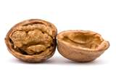](http://rds.yahoo.com/_ylt=A0PDoS12xqVN6kwAeWeJzbkF;_ylu=X3oDMTBpZTByOGFiBHBvcwMyBHNlYwNzcgR2dGlkAw--/SIG=1htso0ch8/EXP=1302738678/**http%3a/images.search.yahoo.com/images/view%3fback=http%253A%252F%252Fimages.search.yahoo.com%252Fsearch%252Fimages%253Fp%253Dwalnut%2526ei%253Dutf-8%2526y%253DSearch%26w=700%26h=466%26imgurl=www.faqs.org%252Fphoto-dict%252Fphotofiles%252Flist%252F474%252F854walnut.jpg%26rurl=http%253A%252F%252Fwww.faqs.org%252Fphoto-dict%252Fphrase%252F474%252Fwalnut.html%26size=84KB%26name=walnut%2b-%2bphoto%252Fp...%26p=walnut%26oid=746074036a7432469afe45092c327de6%26fr2=%26no=2%26tt=3290000%26sigr=11l3d15e4%26sigi=11pobjhj4%26sigb=127a73bc9%26.crumb=5L4N1FN/y)[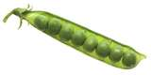](http://rds.yahoo.com/_ylt=A0PDoTCzxqVNEAQAZLyJzbkF;_ylu=X3oDMTBqamdoM3Q5BHBvcwMxMgRzZWMDc3IEdnRpZAM-/SIG=1jsisbirm/EXP=1302738739/**http%3a/images.search.yahoo.com/images/view%3fback=http%253A%252F%252Fimages.search.yahoo.com%252Fsearch%252Fimages%253Fp%253Dpeas%252Bin%252Ba%252Bpod%2526sado%253D1%2526ei%253Dutf-8%2526fr2%253Dsg-gac%26w=1344%26h=680%26imgurl=upload.wikimedia.org%252Fwikipedia%252Fcommons%252F5%252F5b%252FNCI_peas_in_pod.jpg%26rurl=http%253A%252F%252Fcommons.wikimedia.org%252Fwiki%252FFile%253ANCI_peas_in_pod.jpg%26size=202KB%26name=File%253ANCI%2bpeas%2bin...%26p=peas%2bin%2ba%2bpod%26oid=ca393cebf22b70db92d88e86f9736db5%26fr2=sg-gac%26no=12%26tt=88200%26sigr=11qh4l32k%26sigi=11vukgcck%26sigb=12njbkrkq%26.crumb=5L4N1FN/y)

**Seeds:**

1. When do seeds begin to grow? _____________________________________________________________________________________________

2. How do seed adaptations help them survive? __________________________________________________________________________________________________________________________________________________________________________________________

3. What are the two types of adaptations? A) ___________________________B)_________________________

4. What is a physical adaptation? _____________________________________________________________________________________________

5. What is a behavioral adaptation? _____________________________________________________________________________________________

**Seed Dispersal:**

1. True or False: Most plants produce a large number of seeds.

2. Why do they produce a large number of seeds? _____________________________________________________________________________________________

3. What must a seed need to happen in order for it to survive? _____________________________________________________________________________________________

4. What are certain adaptations that seeds have?

A)___________________________________________________________________________________________

B)___________________________________________________________________________________________

C)___________________________________________________________________________________________

D)___________________________________________________________________________________________

Label the pictures below as to which adaptation helps the plant adapt.

[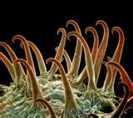](http://rds.yahoo.com/_ylt=A0PDoS1A56ZNRh0AJvCJzbkF;_ylu=X3oDMTBpZm5udGl1BHBvcwM1BHNlYwNzcgR2dGlkAw--/SIG=1lohro2b6/EXP=1302812608/**http%3a/images.search.yahoo.com/images/view%3fback=http%253A%252F%252Fimages.search.yahoo.com%252Fsearch%252Fimages%253Fp%253Dplant%252Bseeds%252Bwith%252Bhooks%2526rs%253D0%2526fr%253Dyfp-t-701%26w=600%26h=535%26imgurl=c.photoshelter.com%252Fimg-get%252FI0000gO4cWmUzvsY%252Fs%252F600%252F900059.jpg%26rurl=http%253A%252F%252Fvisualsunlimited.photoshelter.com%252Fgallery-image%252FDr-Richard-Kessel%252FG00002iBlh8co7x8%252FI0000gO4cWmUzvsY%252FP0000VLJ5TKE.GFk%26size=189KB%26name=Cocklebur%2b%2528Xanth...%26p=plant%2bseeds%2bwith%2bhooks%26oid=f6ecb0d93369239a141a6c47b08ac072%26fr2=%26no=5%26tt=1900%26sigr=13rldjtcs%26sigi=11s9koqng%26sigb=12npfreen%26.crumb=5L4N1FN/ye) [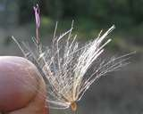](http://rds.yahoo.com/_ylt=A0PDoYCR56ZNEmAACuOJzbkF;_ylu=X3oDMTBpZTByOGFiBHBvcwMyBHNlYwNzcgR2dGlkAw--/SIG=1lnoi141c/EXP=1302812689/**http%3a/images.search.yahoo.com/images/view%3fback=http%253A%252F%252Fimages.search.yahoo.com%252Fsearch%252Fimages%253Fp%253Dplant%252Bseeds%252Bwith%252Bwings%252Bor%252Bthin%252Bhair%2526norw%253D1%2526ei%253DUTF-8%2526fr%253Dyfp-t-701%2526fr2%253Dsp-qrw-corr-top%26w=540%26h=434%26imgurl=www.backyardnature.net%252Fn%252F09%252F090906cc.jpg%26rurl=http%253A%252F%252Fwww.backyardnature.net%252Fn%252Fh%252Fbull-thi.htm%26size=30KB%26name=Notice%2bthat%2bthe%2b...%26p=plant%2bseeds%2bwith%2bwings%2bor%2bthin%2bhair%26oid=484861f38672f6339c5d9d6b002f1ac1%26fr2=sp-qrw-corr-top%26norw=1%26no=2%26tt=10%26sigr=11e86t2ro%26sigi=118j920kb%26sigb=143d5mnil%26.crumb=5L4N1FN/ye) [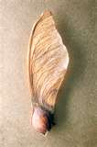](http://rds.yahoo.com/_ylt=A0PDoYC056ZNNWAAmNuJzbkF;_ylu=X3oDMTBqY2pzbGhoBHBvcwMxMQRzZWMDc3IEdnRpZAM-/SIG=1jp7dss7c/EXP=1302812724/**http%3a/images.search.yahoo.com/images/view%3fback=http%253A%252F%252Fimages.search.yahoo.com%252Fsearch%252Fimages%253Fp%253Dplant%252Bseeds%252Bwith%252Bwings%2526ei%253Dutf-8%2526y%253DSearch%2526fr%253Dyfp-t-701%26w=470%26h=709%26imgurl=upload.wikimedia.org%252Fwikipedia%252Fcommons%252F7%252F72%252FMaple-seed.jpg%26rurl=http%253A%252F%252Fgalleyproofs.blogspot.com%252F2009_07_01_archive.html%26size=140KB%26name=...%2bseed.%2bFrom%2bh...%26p=plant%2bseeds%2bwith%2bwings%26oid=899beb19dd43548a888309786f1fd269%26fr2=%26no=11%26tt=8380%26sigr=11opvr4ud%26sigi=11qka2apd%26sigb=134odurvi%26.crumb=5L4N1FN/ye) [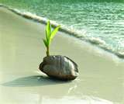](http://rds.yahoo.com/_ylt=A0PDoYDa56ZNB2AALsmJzbkF;_ylu=X3oDMTBqMjRpazg1BHBvcwMxMARzZWMDc3IEdnRpZAM-/SIG=1k65hrbdp/EXP=1302812762/**http%3a/images.search.yahoo.com/images/view%3fback=http%253A%252F%252Fimages.search.yahoo.com%252Fsearch%252Fimages%253Fp%253Dplant%252Bseeds%252Bthat%252Bfloat%252Bin%252Bwater%2526ei%253Dutf-8%2526fr%253Dyfp-t-701%26w=484%26h=408%26imgurl=science.jrank.org%252Fkids%252Farticle_images%252Ffood_p31.jpg%26rurl=http%253A%252F%252Fscience.jrank.org%252Fkids%252Fpages%252F72%252FALL-ABOUT-SEEDS.html%26size=86KB%26name=-%2bHow%2bDo%2bSeeds%2bF...%26p=plant%2bseeds%2bthat%2bfloat%2bin%2bwater%26oid=8da4d6acb9775c2cf5169c87c67736b4%26fr2=%26no=10%26tt=1590%26sigr=11rpsa58v%26sigi=11i1ng2c4%26sigb=134gl0idh%26.crumb=5L4N1FN/ye)

___________ ____________ ________ _____________

**Color:**

1. What are the various ways flowers come in?

_____________________, ________________________, _____________________

2. Why are petals colored and scented? _____________________________________________________________________________________________

3. What if the plant doesn’t have a flower, what could attract insects for pollination? _____________________________________________________________________________________________[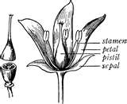](http://rds.yahoo.com/_ylt=A0PDoYAI6KZN8l8Am92JzbkF;_ylu=X3oDMTBpc2ozM2gzBHBvcwM0BHNlYwNzcgR2dGlkAw--/SIG=1j8t87m4s/EXP=1302812808/**http%3a/images.search.yahoo.com/images/view%3fback=http%253A%252F%252Fimages.search.yahoo.com%252Fsearch%252Fimages%253Fp%253Dparts%252Bof%252Ba%252Bflower%2526ei%253Dutf-8%2526fr%253Dyfp-t-701%26w=700%26h=574%26imgurl=etc.usf.edu%252Fclipart%252F19800%252F19873%252Fflowerparts_19873_lg.gif%26rurl=http%253A%252F%252Fetc.usf.edu%252Fclipart%252F19800%252F19873%252Fflowerparts_19873.htm%26size=45KB%26name=Parts%2bof%2ba%2bflowe...%26p=parts%2bof%2ba%2bflower%26oid=dabddc1511542df482df974971808be8%26fr2=%26no=4%26tt=868000%26sigr=11snag609%26sigi=11o09hk68%26sigb=12mdrsipe%26.crumb=5L4N1FN/ye)

**Response to Light:**

1. What is one thing a plant needs to survive? _____________________

2. What does it use the light for? _____________________________________________________________________________________________

3. What does the plant do to its leave to receive light? _____________________________________________________________________________________________

4. What does the plant do to its stems to receive light? _____________________________________________________________________________________________

**Habitats:**

1.What do habitats provide?

* ____________________
* ____________________
* ____________________
* ____________________
* ____________________
* ____________________

2. Can a plant survive in a habitat that does not offer it its basic needs? ________

3. What are the specific needs that characteristics of a habitat can provide depending on a particular plant?

a)__________________ b)___________________ c)_________________________

4. Habitats can be: a)___________________________________________________________________________________________

b)___________________________________________________________________________________________

5. What is an example of a large habitat required for a plant? _____________________________________________________________________________________________

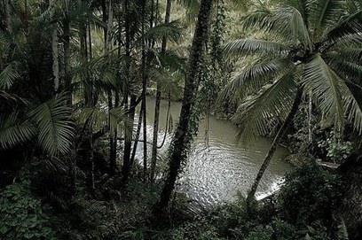 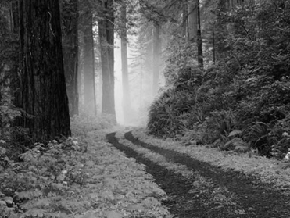

6. What are examples of a small habitat required for a plant? __________________________________________________________________________________________________________________________________________________________________________________________

[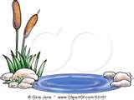](http://rds.yahoo.com/_ylt=A0PDoYDy6KZNHGAAxt6JzbkF;_ylu=X3oDMTBqMjRpazg1BHBvcwMxMARzZWMDc3IEdnRpZAM-/SIG=1je9oald5/EXP=1302813042/**http%3a/images.search.yahoo.com/images/view%3fback=http%253A%252F%252Fimages.search.yahoo.com%252Fsearch%252Fimages%253Fp%253Dpond%252Bclip%252Bart%2526ei%253Dutf-8%26w=450%26h=340%26imgurl=images.clipartof.com%252Fsmall%252F53151-Royalty-Free-RF-Clipart-Illustration-Of-A-Natural-Pond-With-Aquatic-Plants.jpg%26rurl=http%253A%252F%252Fwww.clipartof.com%252Fdetails%252Fclipart%252F53151.html%26size=43KB%26name=...%2b-Free%2b%2528RF%2529%2bC...%26p=pond%2bclip%2bart%26oid=1ac62839490f6e51b376b3e4e443d53b%26fr2=%26no=10%26tt=7080%26sigr=11jbtlrmm%26sigi=13fckhmtj%26sigb=1251l4rc8%26.crumb=5L4N1FN/ye) [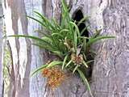](http://rds.yahoo.com/_ylt=A0PDoYBs6aZN.l8AKwKJzbkF;_ylu=X3oDMTBqaTFoaGxvBHBvcwMxNwRzZWMDc3IEdnRpZAM-/SIG=1kkmc9oki/EXP=1302813164/**http%3a/images.search.yahoo.com/images/view%3fback=http%253A%252F%252Fimages.search.yahoo.com%252Fsearch%252Fimages%253Fp%253Dorchid%252Bflowers%252Bgrowing%252Bon%252Btree%2526ei%253Dutf-8%26w=750%26h=563%26imgurl=las.new-england.net.au%252Fwp-content%252Fuploads%252F2006%252F11%252Fimages%252F20061112-018-dendrobium-sml.jpg%26rurl=http%253A%252F%252Flas.new-england.net.au%252F2006%252F11%252F17%252Fepiphyte%252F%26size=131KB%26name=Orchid%2bgrowing%2bi...%26p=orchid%2bflowers%2bgrowing%2bon%2btree%26oid=f5a9e8c550692a3e19d763962fae9316%26fr2=%26no=17%26tt=16600%26sigr=11i917hlg%26sigi=12odm8buo%26sigb=12m9i50v0%26.crumb=5L4N1FN/ye)

7. Resources in an environment can keep A LARGE NUMBER/ ONLY A CERTAIN NUMBER of plants.

8. What can effect the survival of plants in a habitat? ______________________

9. What are some rapid changes that occur naturally?

* _______________
* _______________
* _______________
* _______________
* _______________
* _______________
* _______________
* _______________

Label the examples in the pictures below.

[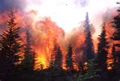](http://rds.yahoo.com/_ylt=A0PDoYCf6aZN9F8ABP6JzbkF;_ylu=X3oDMTBpdnJhMHUzBHBvcwMxBHNlYwNzcgR2dGlkAw--/SIG=1iefi48do/EXP=1302813215/**http%3a/images.search.yahoo.com/images/view%3fback=http%253A%252F%252Fimages.search.yahoo.com%252Fsearch%252Fimages%253Fp%253Dwildfire%2526ei%253Dutf-8%26w=4179%26h=2832%26imgurl=www.lternet.edu%252Fgallery%252Fd%252F1134-4%252FBNZ_wildfire.jpg%26rurl=http%253A%252F%252Fwww.lternet.edu%252Fgallery%252Fsites%252Fbnz%252FBNZ_wildfire.jpg.html%253Fg2_imageViewsIndex%253D1%26size=1%252C016KB%26name=Wildfire%2bin%2bAlas...%26p=wildfire%26oid=28d10ec5fca0d11302a1ec28b37d4127%26fr2=%26no=1%26tt=571000%26sigr=12jqo0s9o%26sigi=11h9j245f%26sigb=1204ga41l%26.crumb=5L4N1FN/ye) [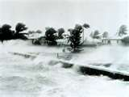](http://rds.yahoo.com/_ylt=A0PDoYC86aZNHWAAThOJzbkF;_ylu=X3oDMTBqY2pzbGhoBHBvcwMxMQRzZWMDc3IEdnRpZAM-/SIG=1ft181i0p/EXP=1302813244/**http%3a/images.search.yahoo.com/images/view%3fback=http%253A%252F%252Fimages.search.yahoo.com%252Fsearch%252Fimages%253Fp%253Dhurricanes%2526ei%253Dutf-8%26w=700%26h=529%26imgurl=www.ecoenquirer.com%252Fancient-hurricane.jpg%26rurl=http%253A%252F%252Fwww.ecoenquirer.com%252Fancient-hurricane.htm%26size=59KB%26name=Photographic%2bevi...%26p=hurricanes%26oid=8f27f2cab82276eabdd6dfce201ffd8f%26fr2=%26no=11%26tt=633000%26sigr=11guj8vjd%26sigi=119km0a35%26sigb=122avocbl%26.crumb=5L4N1FN/ye) [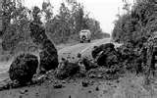](http://rds.yahoo.com/_ylt=A0PDoTEB6qZNtRIAXeCJzbkF;_ylu=X3oDMTBpZTByOGFiBHBvcwMyBHNlYwNzcgR2dGlkAw--/SIG=1ih4i26lm/EXP=1302813313/**http%3a/images.search.yahoo.com/images/view%3fback=http%253A%252F%252Fimages.search.yahoo.com%252Fsearch%252Fimages%253Fp%253Dlandslides%252Bclipart%2526ei%253Dutf-8%26w=800%26h=500%26imgurl=hvo.wr.usgs.gov%252Fearthquakes%252Fdestruct%252F1975Nov29%252Flandslide_l.jpg%26rurl=http%253A%252F%252Fpublicdomainclip-art.blogspot.com%252F2006%252F04%252Fweather-earthquake.html%26size=85KB%26name=Public%2bDomain%2bCl...%26p=landslides%2bclipart%26oid=da22177783b7d6c08ee259d3873b6d4d%26fr2=%26no=2%26tt=88%26sigr=128hebcv7%26sigi=11uv04i5m%26sigb=12a6jm0bl%26.crumb=5L4N1FN/ye)[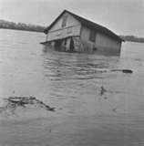](http://rds.yahoo.com/_ylt=A0PDoTEs6qZNsRIAQiWJzbkF;_ylu=X3oDMTBpaWhqZmNtBHBvcwMzBHNlYwNzcgR2dGlkAw--/SIG=1fr0uv8cg/EXP=1302813356/**http%3a/images.search.yahoo.com/images/view%3fback=http%253A%252F%252Fimages.search.yahoo.com%252Fsearch%252Fimages%253Fp%253Dflood%2526ei%253Dutf-8%26w=1064%26h=1073%26imgurl=www.mariettapa.com%252Fimages%252F1936.JPG%26rurl=http%253A%252F%252Fwww.mariettapa.com%252Fflood_1936_buildingfloat.html%26size=41KB%26name=...%2bBuilding%2bFlo...%26p=flood%26oid=afa3056319fee217bd765c4dff20b141%26fr2=%26no=3%26tt=2550000%26sigr=11nbcca6n%26sigi=1122n8qvi%26sigb=11t3782vu%26.crumb=5L4N1FN/ye)[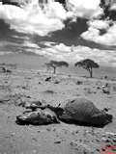](http://rds.yahoo.com/_ylt=A0PDoTFF6qZNlRIAyBiJzbkF;_ylu=X3oDMTBpc2ozM2gzBHBvcwM0BHNlYwNzcgR2dGlkAw--/SIG=1hn43sol1/EXP=1302813381/**http%3a/images.search.yahoo.com/images/view%3fback=http%253A%252F%252Fimages.search.yahoo.com%252Fsearch%252Fimages%253Fp%253Ddrought%2526ei%253Dutf-8%26w=600%26h=800%26imgurl=whitezulu.com%252Fwp-content%252Fuploads%252F2009%252F11%252F2009-10-19-12124-Drought.jpg%26rurl=http%253A%252F%252Fwhitezulu.com%252F2009%252F11%252F17%252Fdrought-i%252F%26size=232KB%26name=Drought%2bI%2b%253A%2bThe%2b...%26p=drought%26oid=f21e0d13cbc238d96df4ed2287f0bb92%26fr2=%26no=4%26tt=514000%26sigr=11a2vmnb0%26sigi=125bv32ad%26sigb=11vo9rhkb%26.crumb=5L4N1FN/ye)[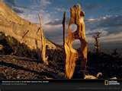](http://rds.yahoo.com/_ylt=A0PDoS6N6qZN6nwAKSyJzbkF;_ylu=X3oDMTBpaWhqZmNtBHBvcwMzBHNlYwNzcgR2dGlkAw--/SIG=1m8jm1k8i/EXP=1302813453/**http%3a/images.search.yahoo.com/images/view%3fback=http%253A%252F%252Fimages.search.yahoo.com%252Fsearch%252Fimages%253Fp%253Derosion%252Band%252Bweathering%2526ei%253Dutf-8%26w=800%26h=600%26imgurl=science.nationalgeographic.com%252Fstaticfiles%252FNGS%252FShared%252FStaticFiles%252FScience%252FImages%252FContent%252Fweathered-trees-391221-sw.jpg%26rurl=http%253A%252F%252Fjoubonjatra.com%252Fforums%252Fshowthread.php%252F25990-Natural-Beauty%2521%2521Erosion-and-Weathering%26size=149KB%26name=Re%253A%2bNatural%2bBeau...%26p=erosion%2band%2bweathering%26oid=8b166ee31db72f8a71dcbf26055af709%26fr2=%26no=3%26tt=10100%26sigr=12pcile2u%26sigi=13mf4ldcm%26sigb=12eq658v3%26.crumb=5L4N1FN/ye)

10. What are some slow changes that occur naturally?

* ____________________________________________________________
* ____________________________________________________________

11. What will happen if these processes occur? __________________________________________________________________________________________________________________________________________________________________________________________

12. What else can also change habitats? ________________

13. How can humans change a habitat? _____________________________________________________________________________________________

14. What is another way to change a habitat? _____________________________________________________________________________________________

15. What is a possible outcome if a plant cannot adapted to this new environment? _______________________

16. What is extinction? _________________________________________________________________________________

**Food Chains:**

1. What is energy and how does it help? _____________________________________________________________________________________________

2. In a habitat, what provides most of the energy? _____________________

3. What is a food chain? _____________________________________________________________________________________________

4. What are the three types of organisms in a food chain?

A)_______________ B)__________________C)____________________

5. What are producers? _____________________________________________________________________________________________

6. Where are producers on a food chain? _____________

7. What are consumers? _____________________________________________________________________________________________

8. What are decomposers? _____________________________________________________________________________________________

9. Where are decomposers on a food chain? ________________

