* You may use this to guide your studying of our Animals Unit
3.2.1 Illustrate the life cycles of seed plants and various animals and summarize how they grow and are adapted to conditions within their habitats.
3.2.2 Explain how physical and behavioral adaptations allow organisms to survive (including hibernation, defense, locomotion, movement, food obtainment, and camouflage for animals and seed dispersal, color, and response to light for plants).
3.2.3 Recall the characteristics of an organism’s habitat that allow the organism to survive there.
3-2.4 Explain how changes in the habitats of plants and animals affect their survival.
3.2.5 Summarize the organization of simple food chains (including the roles of producers, consumers, and decomposers).

1. What is a life cycle? _______________________________________________________________________
___________________________________________________________________________________________
2. What allows animals to go through a life cycle where all their needs are met? _____________________
___________________________________________________________________________________________
3. What are adaptations? _____________________________________________________________________
___________________________________________________________________________________________
4. An adaptation can help an animal do what in its habitat? _______________________________________
___________________________________________________________________________________________
5. What are all the components of a plant’s habitat?
* _______________________ * _______________________ * _______________________
* _______________________ * _______________________ * _______________________
Life Cycles of Various Animals
- Are the stages of the life cycle the same for all animals? ____________________________________
- Some animals ________________________________________________________________________
_______________________________________________________________________________________
- As the babies grow, they change in ______________________. Others might change their ____________________, ____________________, and _____________________________________.
~ Example: ___________________ and __________________ give birth to babies that look like the adult, just ________________________________.
- Some animals ____________________________________ and then ___________________________
in their life cycle.
- These changes may be in ________________________, __________________, _________________, or _____________________________________________________.
~ What are these changes called? _______________________________________________________
~ Example: A beetle’s life cycle = ________________ then ______________ then _______________
and finally __________________.
A grasshopper’s life cycle = ________________ then _____________________________
and finally __________________.
- What are the three types of life cycles? A.) ________________ -> __________________
B.) ________________ -> __________________ -> __________________
C.) ________________ -> __________________ -> __________________ -> __________________
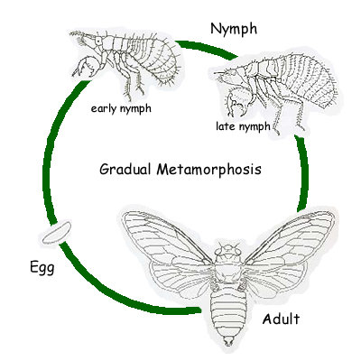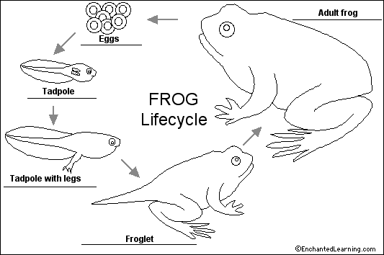
_____________________ __________________________
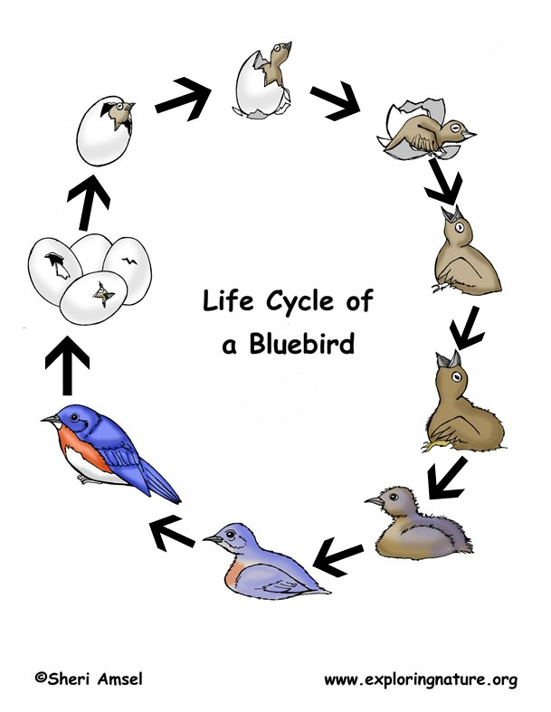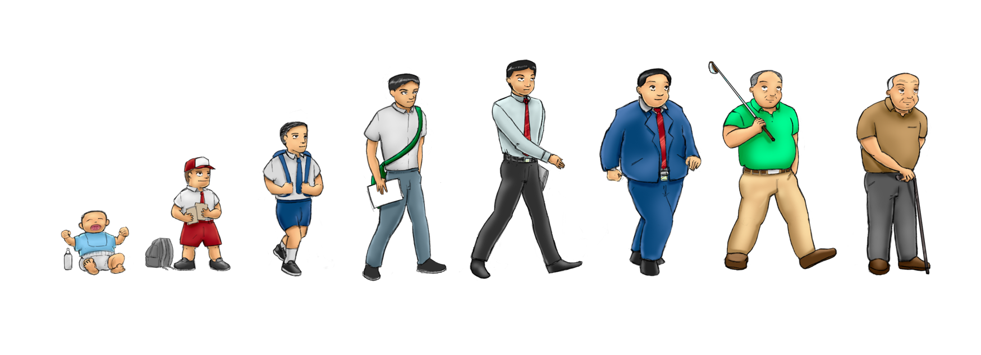
___________________ _______________________________
Adaptations of Animals:

Type of habitat | Animal Adaptations
cold temperature s
water habitat
where food is scarce
very hot temperatures

Physical and Behavioral Adaptations of Animals:
- What are physical adaptations? ________________________________________________________
____________________________________________________________________________________
- What are behavioral adaptations? _____________________________________________________
____________________________________________________________________________________
- Some adaptations of animals help the:
~ __________________________________________________________________________________
~ __________________________________________________________________________________
~ __________________________________________________________________________________

- HIBERNATION:
- What is hibernation? __________________________________________________________________
____________________________________________________________________________________
- What happens during hibernation? _____________________________________________________
____________________________________________________________________________________
- What do many animals do in the autumn months? _________________________________________
____________________________________________________________________________________
(ex. of animals: ______________, _____________, _______________, ________________________)
- What do hibernating animals do to keep safe from the winter cold and enemies? _____________
____________________________________________________________________________________
- What happens when the temperatures rise in the spring? _________________________________
____________________________________________________________________________________
- DEFENSE:
- What is the purpose of defense adaptations? ____________________________________________
____________________________________________________________________________________
EXAMPLES INCLUDE:
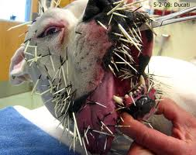
_________________________
physical DEFENSE adaptations: _________________________
_________________________
behavioral DEFENSE adaptations: _________________________
_________________________
_________________________
- LOCOMOTION:
- What is locomotion? __________________________________________________________________
- Why is locomotion important? __________________________________________________________
____________________________________________________________________________________
- TRUE or FALSE : Animals have special structures for moving depending on where they live.
- EXAMPLES INCLUDE: ______________________
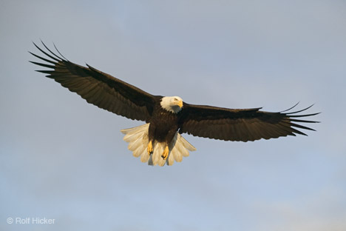
living above ground ______________________
______________________
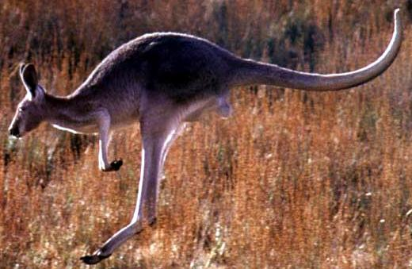
______________________
living on the ground ______________________
______________________
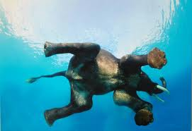
______________________
living in the water ______________________
______________________

- MOVEMENT:
- What is migration? ___________________________________________________________________
____________________________________________________________________________________
- What does this behavior allow animals to do? ___________________________________________
____________________________________________________________________________________
EXAMPLE of Migration: ________________________________________________________________
- FOOD OBTAINMENT:
- TRUE or FALSE : Animals have special structures used for getting food.
EXAMPLES INCLUDE: ________________________________, _______________________________, _______________________, ____________________________________________________________
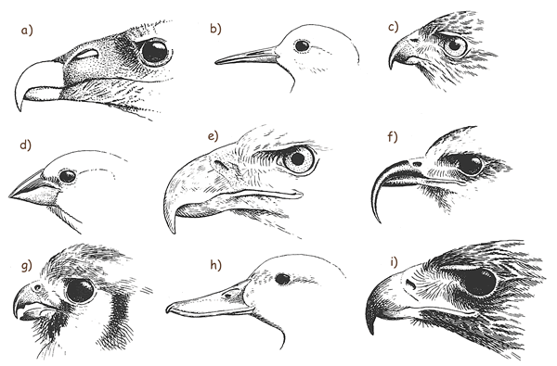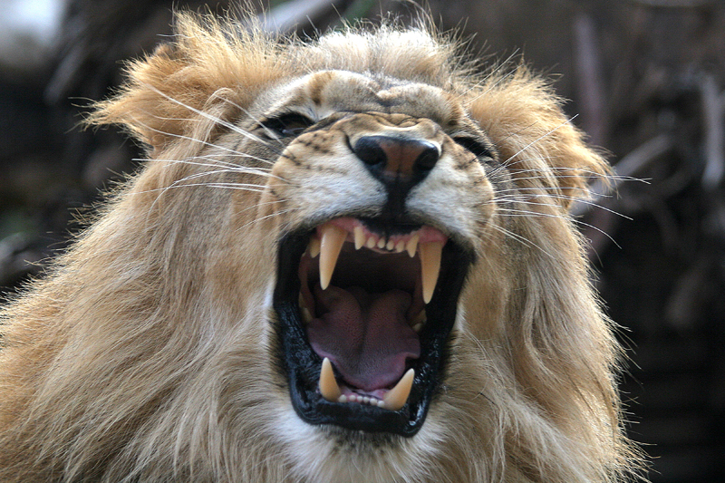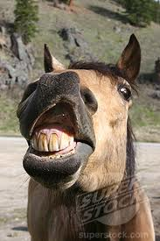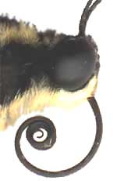
- CAMOUFLAGE:
- What is camouflage? _________________________________________________________________
____________________________________________________________________________________
- What is camouflage important?
a.)__________________________________________________________________________________
b.)__________________________________________________________________________________
* What animal is hidden in each picture because of it’s camouflage?
