Habitats for Plants
What Habitats Offer to Plants and Animals:

Organisms have needs for survival that are found in their particular habitats. Organisms can only survive in an area where its basic needs (air, food, water, shelter or space, and light) can be met. A habitat offers a range of conditions, for example water, air, food, shelter or space, or sunlight, which allow some organisms to live there.

Small and Large Types of Habitats:

The specific characteristics of the habitat that allow the needs of energy, growth, and protection to be met are dependent upon the particular plant or animal. The habitat for some animals and plants may cover a large area. Some examples may be: grazing animals may need lots of area to get enough food, birds fly from place to place to get food, or large trees will grow in areas where enough water is available for their growth. Other animals or plants have habitats that may be a small part of a larger environment. Some examples may be squirrels may make their nests in one tree in a forest, some small insects may live under a fallen log in the forest, orchid flowers live by hanging on trees found only in warm, wet areas, or water lilies live in ponds in the shallow water.
Examples of small habitats

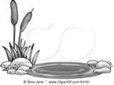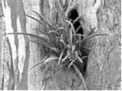
Examples of large habitats

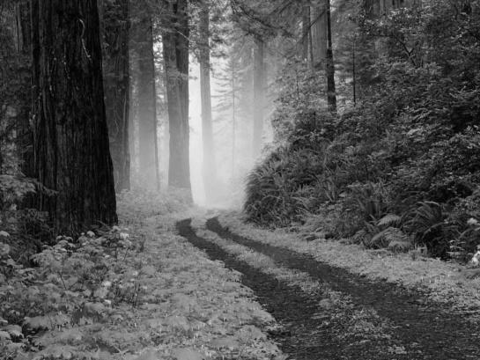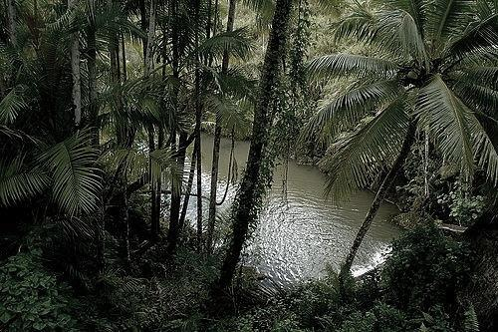

Changes in a Plant’s Habitat:

Resources (basic needs) within a habitat can keep only a certain number of plants and animals alive. This depends on how well the habitat provides for the needs of the plant or animal. Changes in a habitat can affect the survival of a plant and animal. There are many changes that can occur within a habitat that would force the animals or plants to change or adapt to survive.

Rapid Changes that Affect a Habitat:

Habitat change can occur naturally. Some changes occur rapidly, for example, disease, fire, hurricanes, landslides, volcanoes, earthquakes, or changes in temperature or amount of rainfall (drought or flood) can change a habitat.
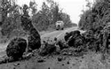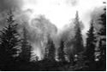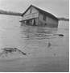

Slow Changes that Affect a Habitat:

Some changes occur slowly, for example, the changes in a plant life due to changes in sunlight (grasses to shrubs to trees), or if erosion occurs, causing the soil to wear away, fewer plants will be able to survive. When these events happen, the habitat usually cannot provide the needs for the animals or plants to survive there anymore.

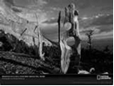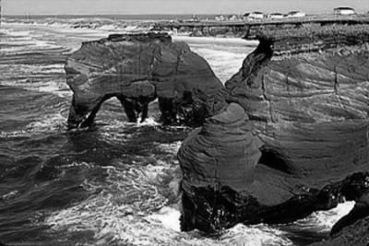

Other Changes that Affect a Habitat:

Humans can also cause habitat changes. For example, clearing land to build homes, buildings, or farmland can cause the animals in that area to have to move to another location for food or shelter. Plants that normally grow there would not find the conditions for their growth available anymore.
Other animals or plants could also move into a habitat taking up needed space and food.

What the Result of Changing Habitats? :

If animals or plants cannot adapt to changes in the environment, extinction (loss of an entire group of organisms) of that type of animal or plant can occur. There have been several animals over the years that have gone extinct. Endangered animals are animals that may go extinct if measures aren’t taken to ensure their survival.
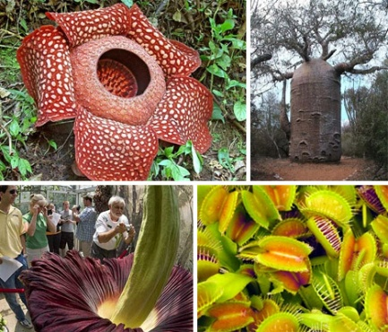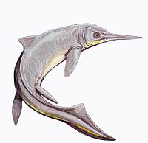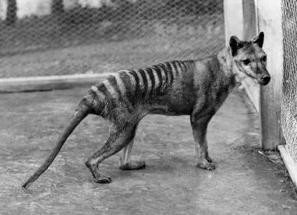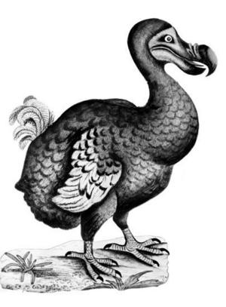

Food Chains:
All organisms need energy to survive. Energy gives the organism its ability to move and do the things it needs to survive. In most habitats, the Sun provides the initial energy which is passed from plants to animals.
When scientists describe the way that energy is passed from one organism to another they use a model called a food chain. A food chain uses arrows to show the direction in which energy is passed and usually contains no more than six organisms.
Food chains have three types of organisms. The role of an organism can be described by how it obtains its energy.
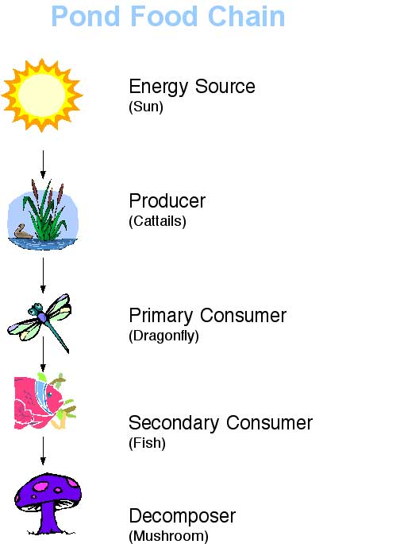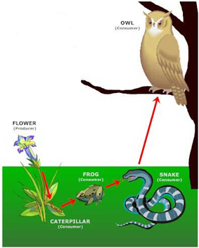

Producers:

Any green plant, which uses sunlight to make food for energy is considered a producer. Producers are the first organisms listed in a food chain, understanding that the Sun provides the initial energy for the plants.
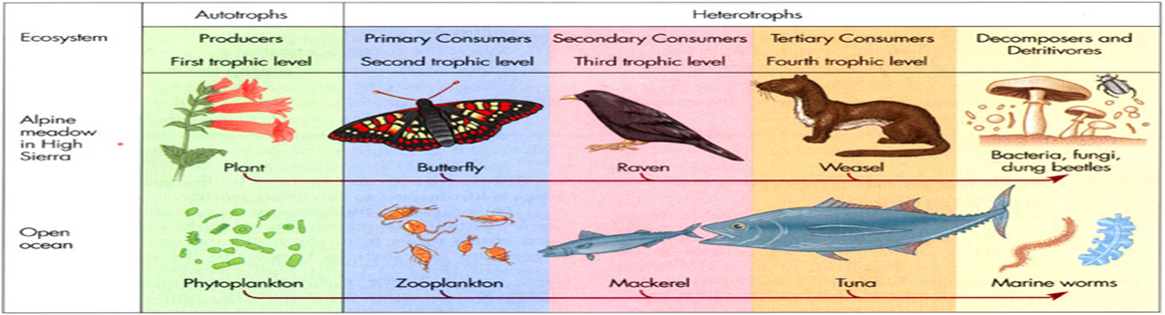

Consumers:
An organism (usually an animal) that obtains its energy by eating other organisms (plants and/or animals) is considered a consumer. A consumer is an organism that cannot create its own food. Some consumers are herbivores or plant eaters. They are animals such as mice or grasshoppers. Some consumers are carnivores or meat eaters. They are plants like the Venus Fly-Trap or animals like a mountain lion. Some consumers are omnivores. They are ones that eat both plants and meat. Some examples would be ants and humans.

Decomposers:

An organism (for example worms, mold, or mushrooms) that obtains its energy by feeding on and breaking down dead plants and animals are considered a decomposer. Decomposers are often not listed in a food chain even though they are always the final link. There are many types of plants and animals that are considered decomposers.
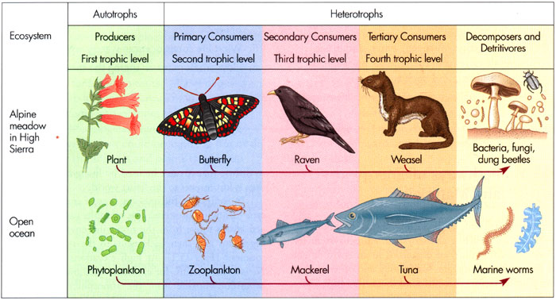

Habitats and Adaptations of Plants:

Every plant and animal has a pattern of growth and development called a life cycle. As seed plants and animals go through their life cycles, they grow within a habitat for which their needs can be met. Plants and animals have adaptations that allow them to survive the conditions within habitats in which they live. An adaptation is a characteristic that improves the organism’s ability to survive. A habitat is a place where an organism or groups of organisms live and obtain the air, food, water, shelter or space, or light needed to survive.

Life Cycle of Seed Plants:

The stages of growth in seed plants that are part of their life cycle are called a seed, seedling and a mature plant.
Seed :
After pollination (the spreading of pollen from flower to flower) occurs, seeds are produced and may be stored in fruits.
Seeds contain tiny undeveloped plants and enough food for growth to start. Seeds need water and warmth to germinate (begin to grow). The outer part of the seed is called a seed coat. It is the protective layer that covers the seed. The inside of the seed contains the embryo and the stored food. The embryo is the tiny plant inside of the seed waiting for germination. The stored food is what feeds the embryo until the plant is able to produce food on its own.
Seed Coat
Embryo
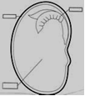
Stored Food
Seedling:
Seedlings produce the parts of the plant that will be needed for the adult plant to survive in its habitat. Roots begin to grow and take in nutrients and water from the habitat. The stem starts to grow towards light and the first leaves form on the stem.
Later, more leaves will form that help the plant make its food.

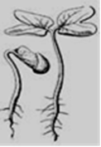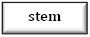
leaves

roots

Mature Plant :
Mature plants have the same structures (for example roots, stems, and leaves) as seedlings, but in addition they develop flowers or cones, which produce seeds.
leaves
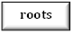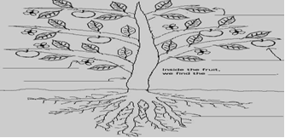
flower
fruit
stem

Adaptations of Seed Plants

Some plants have special structural adaptations for meeting their needs in their particular habitat. Some examples of plant adaptations to conditions in their habitat may be roots, stems, leaves, seeds, flowers or fruits.

Roots:
Roots take in water and nutrients from the habitat. They may also hold the plant in place and store food and water.
Each variety of plant will survive where its roots size, length, and spread are adapted to the habitat. Some examples of root adaptations may be: Water lilies have long roots that can take in nutrients from the muddy bottoms of ponds or lakes. Cacti have roots that spread out close to the surface for living in dry habitats. Carrots and dandelions have a large, thick root that is longer than its other roots. This long root helps the plant survive by reaching far underground to find water and to firmly anchor the plant.
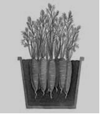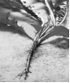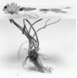
Dadelion Roots
Carrot Roots
Water Lily Roots
cactus Roots

Stems:
Stems move and store water and nutrients in the plant. Stems also provide support and protection for the plant. Some examples of stem adaptations may be: Vines have stems that can climb and stick to various surfaces to ensure that the leaves are exposed to light. Corn and sunflowers have stems that grow thick and strong but remain green and flexible so that they can grow toward the sun. Trees develop woody stems to support their size and provide protection during their long life cycles. Cacti have thick stems that store water when the habitat does not provide it. Some stems have thorns that provide protection.
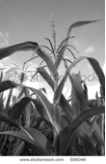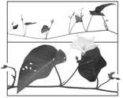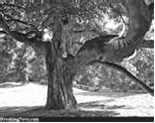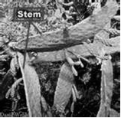
Cactus Stem
Corn Stalk
Vine Stem
Tree Trunk
Leaves:
Leaves produce food for plants in the presence of light. Each variety of plant will survive where its leaf size, texture, thickness, and shape are adapted to the habitat. Some examples of leaf adaptations may be: Water lilies develop wide leaves that allow them to float on the water to capture sunlight to make food. Evergreen trees have leaves that are thin, waxy needles to protect them from freezing and from losing water.
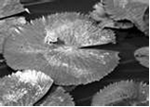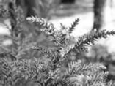
Lily Pad Leaves
Evergreen Tree Leaves or Needles

Flowers:
Flowers often have special sizes, smells, shapes, or colors that attract organisms for pollination.
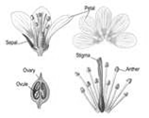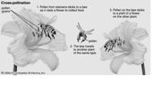

Fruit:
Fruits are formed around the seed to protect it. Some examples of fruit adaptations may be:
Some fruits are moist and fleshy (tomatoes, grapes, or peaches). Fleshy fruits attract animals that eat them helping to disperse the seeds. Others fruits are dry and/or hard (coconuts, walnuts or pea pods).
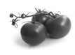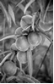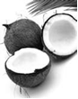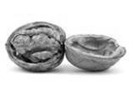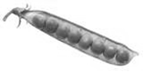
Seeds:
Some seeds begin to grow as soon as conditions allow for germination. Seeds have adaptations that allow them to be dispersed and also to have enough food for the plant until it begins making its own food.

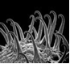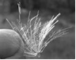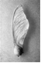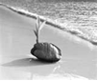
*** Hooked Seed *** Hairs or Feathery Seed *** Winged Seed *** Floating Seed

Physical and Behavioral Adaptations of Plants:

Plants and animals have special traits or characteristics that allow them to survive in their particular habitats. These special traits or characteristics, called adaptations, are necessary for a plant or animal to survive if its surroundings change.

Physical adaptations can be a body structure that an organism has that allows it to meet its needs in its habitat.
Behavioral adaptations can be an activity or action that helps an organism survive in its habitat.

Physical and Behavioral Adaptations of Plants:

Plants cannot move like animals can, but they can respond to a change in their environment. Some examples of plant adaptations for survival include:

Seed dispersal :
Most plants produce a large number of seeds because most seeds do not survive. In order to ensure that seeds will survive, they must be carried away (dispersed) from the parent plant. Some seeds have hooks on them that allow them to attach to animal fur or clothes. Some seeds are able to float in water. Some seeds are light and have wings or thin hairs that allow them to be carried away by wind. Some seeds are eaten by animals and deposited in areas away from the parent plants.
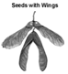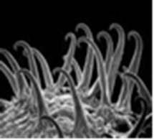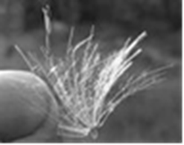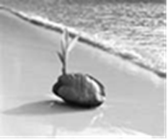
*** Winged Seed *** Hooked Seed *** Hairs or Feathery Seed *** Floating Seed

Color:
Flowers come in a variety of shapes, sizes, and colors. Petals are colored and scented to attract insects and other creatures for the purposes of pollination. The coloration of parts of some plants (fruits for example berries, or flower petals) makes them attractive to some animals (for example birds or bees).
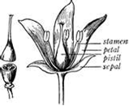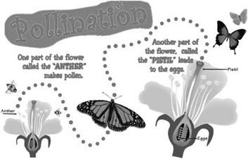
Response to light:
A plant needs sunlight or some other light source to survive. It uses the light for the energy it needs to make its food.

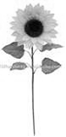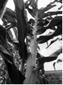
*** Sun flowers and corn stalks respond to light by bending their flexible stems toward the sunlight.

