Earth’s Features & Changes
3-3.5 Illustrate Earth’s saltwater and freshwater features (including oceans, seas, rivers, lakes, ponds, streams, and glaciers).
3.3.6 Illustrate Earth’s land features (including volcanoes, mountains, valleys, canyons, caverns, and islands) by using models, pictures,
diagrams, and maps.
3.3.7 Exemplify Earth materials that are used as fuel, as a resource for building materials, and as a medium for growing plants.
3.3.8 Illustrate changes in Earth’s surface that are due to slow processes (including weathering, erosion, and deposition) and changes that are
due to rapid processes (including landslides, volcanic eruptions, floods, and earthquakes).

Earth’s Water Features:

There are many places on Earth where water is found. Sometimes the water is saltwater and other times it is fresh water. Most of the water on Earth is saltwater. Water is mostly in liquid form in these features, but sometimes it can be solid (ice). Earth’s water features include:
Oceans are large bodies of salt water that surrounds a continent. Seas are large bodies of salt water that is often connected to an ocean. A sea may be partly or completely surrounded by land. Rivers are large, flowing bodies of fresh water that usually empty into a sea or ocean. Streams are small, flowing bodies of fresh water that flow into rivers. Lakes and ponds are areas where water, usually freshwater, are surrounded by land. Lakes and ponds differ in size with ponds usually being smaller than lakes. Glaciers are huge sheets of ice that cover land. They are found where temperatures are very cold, for example, high in the mountains or near the poles of Earth.
SALT Water Features
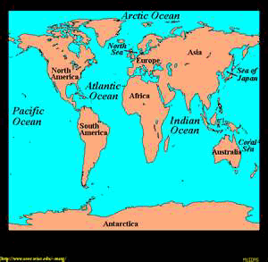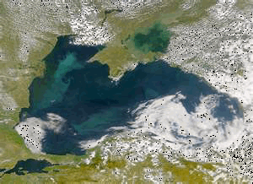
ocean sea

FRESH “flowing” Water Features
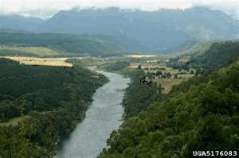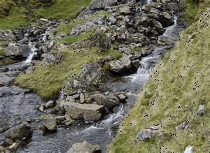
river stream
FRESH Water Features
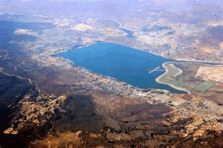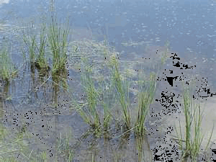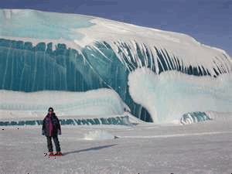
lake pond glacier

1. What are the two types of water found on the Earth? saltwater and freshwater
2. Most of the Earth’s water is made up of saltwater.
3. Water can come in the form of a solid or a liquid. What water feature is an example of water in a solid
form? Ice/glacier
4. What is an ocean? large body of salt water that surrounds a continent
5. What is a sea? large body of saltwater that is often connected to an ocean, could be partly or completely surrounded by land.
6. How are oceans and seas different? Ocean surrounds land, seas are surrounded by land
7. What is a river? Large flowing bodies of fresh water that usually empty into the ocean/sea
8. What is a stream? Small body of flowing water that flows into a river
9. How are rivers and streams different? Rivers are larger than streams. Streams flow into rivers.
10. What are lakes and ponds? Areas where water, usually freshwater, are surrounded by land
11. How are lakes and ponds different from each other? Ponds are smaller
12. How are lakes and ponds different from rivers and streams? Rivers/streams=flowing lakes/ponds=standing water
13. How are lakes and rivers different from oceans and seas? Oceans and seas are much larger also saltwater
14. What is a glacier? Huge sheets of ice that covers land
15. Where would glaciers be located? very cold; high in the mountains and near the poles of the Earth

Earth’s Landform’s:

Earth’s surface has many natural shapes or features called landforms. Earth’s land features that can be seen on models, pictures, diagrams, and maps include:
Volcanoes are an opening in Earth’s surface from which lava flows. As the lava hardens and builds up, a volcanic mountain forms. Mountains are a place on Earth’s surface where the land is much higher than the land that surrounds it. Some mountains are tall and rocky and others are rounded and covered with trees. A mountain area that has a flat top is called a plateau. Valleys are a lowland area between higher areas such as mountains. Sometimes rivers can wear away land to form valleys. Canyons are a deep valley with very steep sides. They are often carved from the Earth by a river. Caverns are a large cave or underground chamber. Caverns or caves are formed underground when water wears away the rock. Islands are an area of land that is entirely surrounded by water. Sometimes islands are located in lakes, or they may be out from the seashore as barrier islands.
Earth’s Landforms
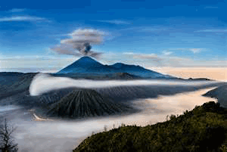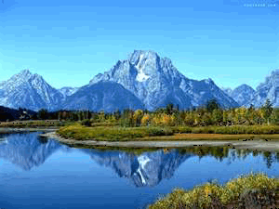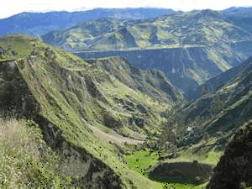
volcano mountains valley
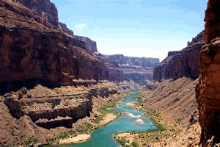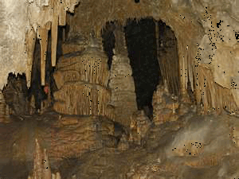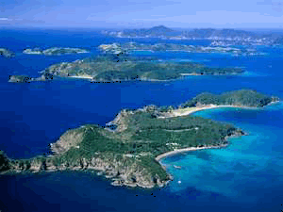
canyon cavern island

1. What is a landform? natural shapes or features on Earth
2. What are various ways that we can see Earth’s landforms? Maps, models, pictures, and diagrams
3. What is a volcano? opening in the Earth’s surface from which lava flows
4. How does a volcanic mountain form? As lava hardens and builds up
5. What is a mountain? Land is much higher than the land around it
6. How do mountains differ from one another? some are tall and rocky and others are rounded and covered with trees
7. What is a mountain with a flat top called? plateau
8. What is a valley? Lowland between mountains
9. What water feature can erode the land to form valleys? rivers
10. What are canyons? deep valley with very steep sides
11. How are canyons formed? also by rivers
12. What is a cavern? Large underground chamber
13. What is another word for a cavern? cave
14. How are caverns formed? water wears away the rock
15. What is an island? Land surrounded by water
16. Where can islands be located besides in the ocean? in lakes or seashore
17. What do you call an island that is out from the seashore? Barrier island

The surface of Earth does change in natural ways. Sometimes the change can be caused by a very slow process and at other times it can be caused by a rapid process. There is often evidence on the surface that these processes have caused a change.

Changes Due to SLOW Processes:

Weathering is when weathering is occurring, Earth materials, for example rocks are being broken apart. Little or big cracks in the rock are evidence that weathering is taking place. Erosion is when erosion is occurring, Earth materials, like rock, sand, and soil, are
being carried away from their original location. Water and wind are often the causes for erosion. Deposition When deposition is occurring, Earth materials that have been eroded are
put in a new location. When the wind stops blowing, sand and soil may be put down in piles as large as dunes. Water may deposit its material at the end of a river and form a delta.
Examples of WEATHERING
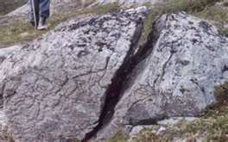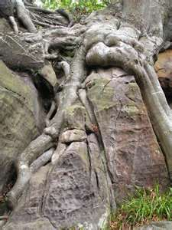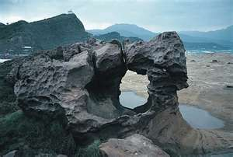

1. What occurs during the process of weathering? Rocks are being broken apart
2. What visible signs show that weathering is occurring in a rock? Little or big cracks
Examples of EROSION
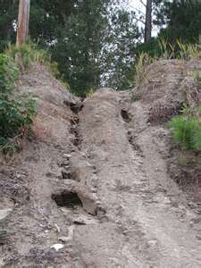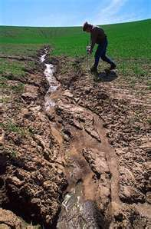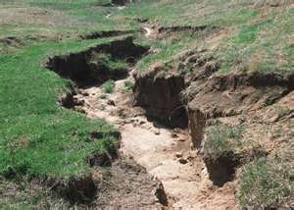

3. What occurs during the process of erosion? Rocks and sand are moved from their original location
4. What are the two causes for erosion to occur? Water and wind

Examples of DEPOSITION
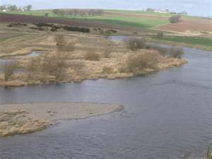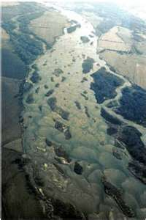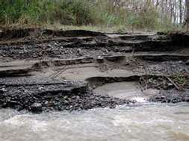
5. What occurs during the process of deposition? Materials that have been eroded and weathered are put in a new location
7. What are the two causes for deposition to occur? Wind and water
8. What are some landforms that can be created due to the process of deposition? Sand dunes or deltas
9. Label correctly the processes of slow changes.
A)Weathering: A rock is slowly being broken apart while laying the valley floor. Cracks
are forming all throughout the rocks.
B)Erosion: The pieces of the rock are now being carried away from the valley floor
by both the river and the wind.
C)Deposition: The eroded pieces of the rock have been placed within parts of the river
adding to the delta and parts of it have been blown and are now settling in a different part adding to the mountain.

Changes Due to RAPID Processes:

When Landslides occur, Earth materials, like rock, sand, and soil, on the side of a slope or cliff drop down to a lower location. Water soaking into the ground often makes this happen. When Volcanic Eruptions occur, Earth material called lava comes out of the volcano flows down the side of the volcanic mountain (or is sent up into the air and lands nearby) where it hardens. The hardened volcanic rock forms new Earth material and often makes the volcanic mountain larger. When Floods occur, a lot of water causes rivers and streams to overflow their banks over the surrounding land around them. Heavy rainfall in the area is usually the cause of a flood. When Earthquakes occur, the surface of the ground shakes and rolls causing damage to the Earth’s surface, like cracks and other openings, and damage to roads and buildings.

1. What are the four rapid processes that change Earth’s surface?
A) landslides
B) volcanic eruptions
C) earthquakes
D) floods
Examples of LANSLIDES
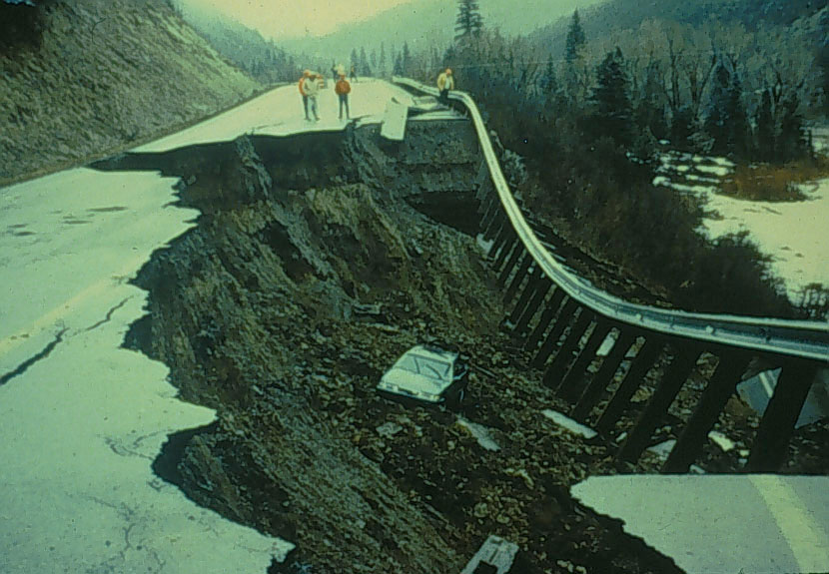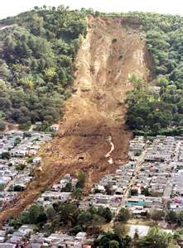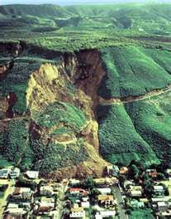
2. What occurs during a landslide? Earth materials, like rock, sand, and soil, on the side of a slope or cliff drop down to a lower location
3. What generally causes the landslide to occur? Water soaking into the ground often makes this happen
Examples of VOLCANIC ERUPTIONS
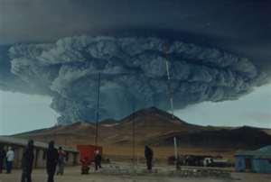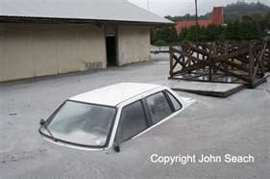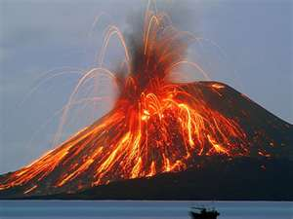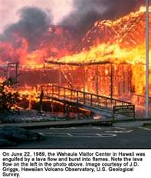

4. What occurs during a volcanic eruption? Earth material called lava comes out of the volcano flows down the side of the volcanic mountain
5. What is the melted rock called once it is erupted from the volcano? lava
6. What forms after the volcanic rock cools and hardens? The hardened volcanic rock forms new Earth material
Examples of FLOODS
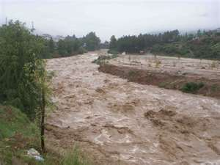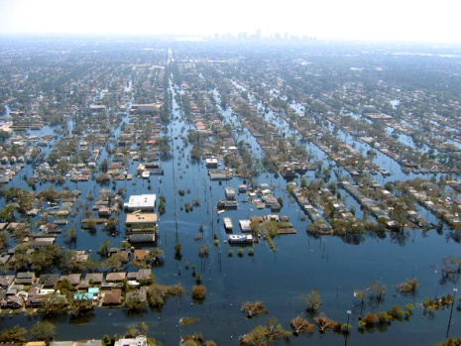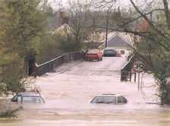
7. What occurs during a flood? a lot of water causes rivers and streams to overflow their banks over the surrounding land around them
8. What is generally the cause of a flood? Heavy rainfall in the area

Examples of EARTHQUAKES
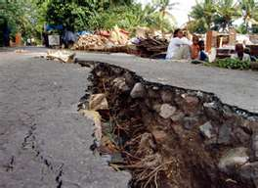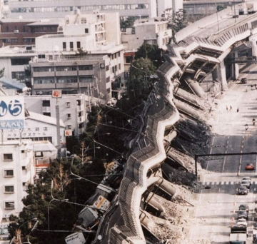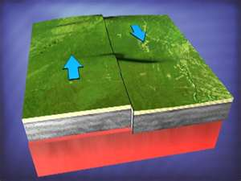
9. What occurs during an earthquake? the surface of the ground shakes and rolls causing damage to the Earth’s surface
10 What are the effects of an earthquake? Cracks to the surface, road damage, and buildings
11. How are a landslide, an earthquake and a volcanic eruption different? _________________________
______________________________________________________________________________________________________________________________________________________________
Examples of TSUNAMI
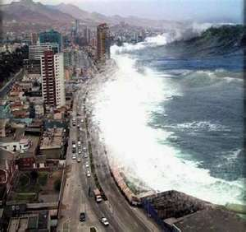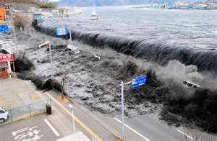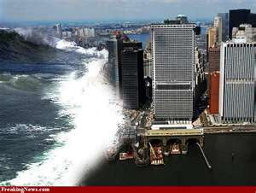
12. What occurs during a tsunami? giant waves come to the shore
13. What causes a tsunami to happen? An underground earthquake in the ocean

